Practice Problems for simulation homework

1. hypothesis test on a single population proportion

**Example from lecture:**

**Given 13 successes out of 25. Hypothesize that the actual proportion is greater than 0.4.**

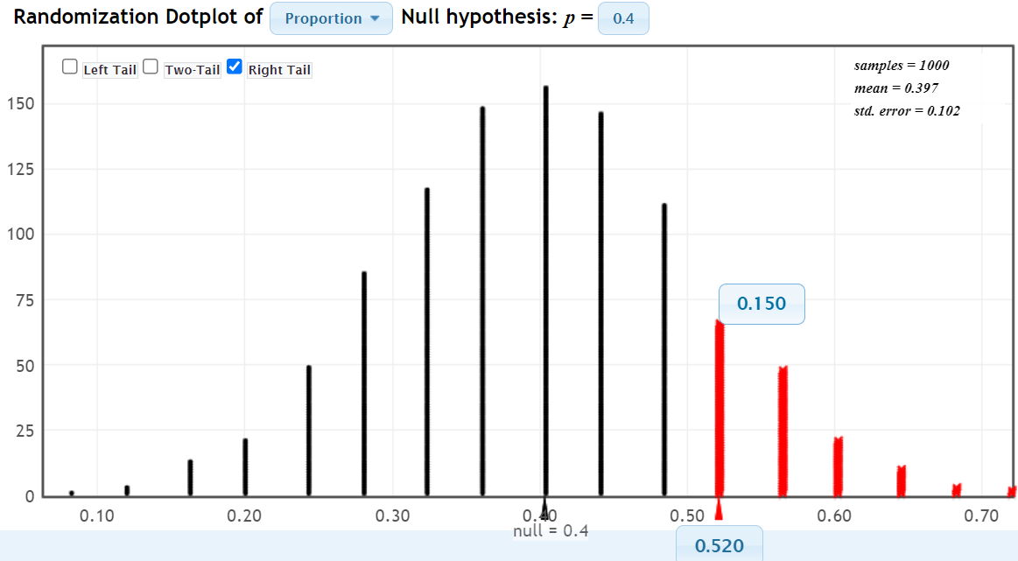Answer: the null hypothesis (p = 0.40) generates a proportion consistent with the observed proportion 15% of the time. If we are using 90% confidence, we would need to see this happening 10% or less of the time. We fail to reject the null hypothesis at 90% confidence.

1. confidence interval for a single population proportion

**Example from lecture: 13 successes out of 25. Construct a 90% confidence interval for the population proportion.**

My solution is that the population proportion is between 0.36 and 0.68, which matches the lecture:

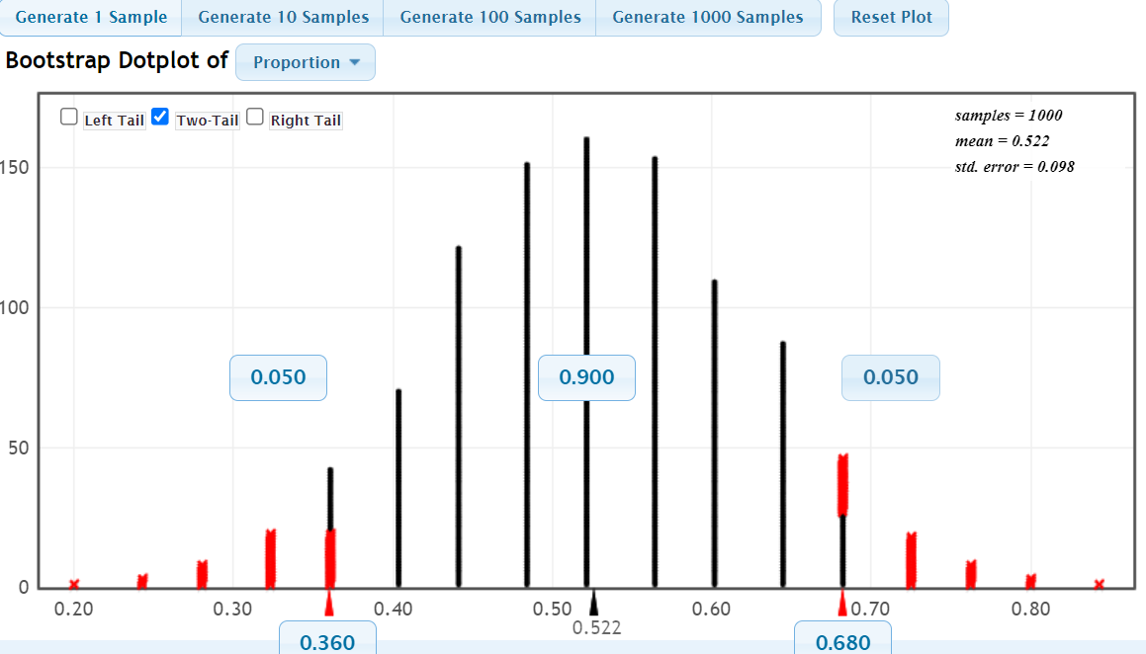

**Example 1: We have a random sample from a population where the sample size is 52 and the number of successes is 31. Find a 90% confidence interval for the population proportion.**

I find that the interval is .481 < p < .712.

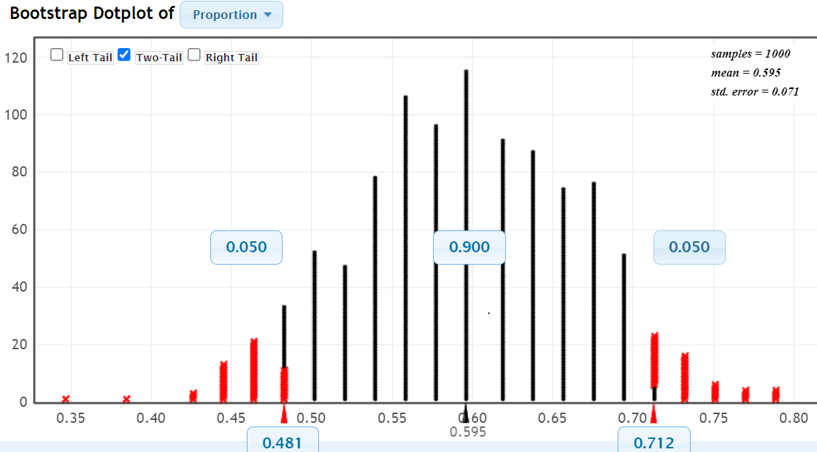

1. hypothesis test on a difference of two independent proportions

**Example 2: We have random samples from two populations and we want to test the claim that the population proportion in Population A is larger than the population proportion in Population B. In the sample from population A, there are 22 successes from 88 trials. In the sample from population B, there are 15 successes from 68 trials. Write the hypotheses and use StatKey to find the p-value.**

My solution:

Alternative Hypothesis: A’s proportion is larger than B’s (A minus B is positive)

Null Hypothesis: pA – pB = 0

Result: Given the null hypothesis (centering the distr. at zero), we get a result at least as extreme as our data (0.029) 40.5% of the time, for a p value of 0.41. We fail to reject the null hypothesis.

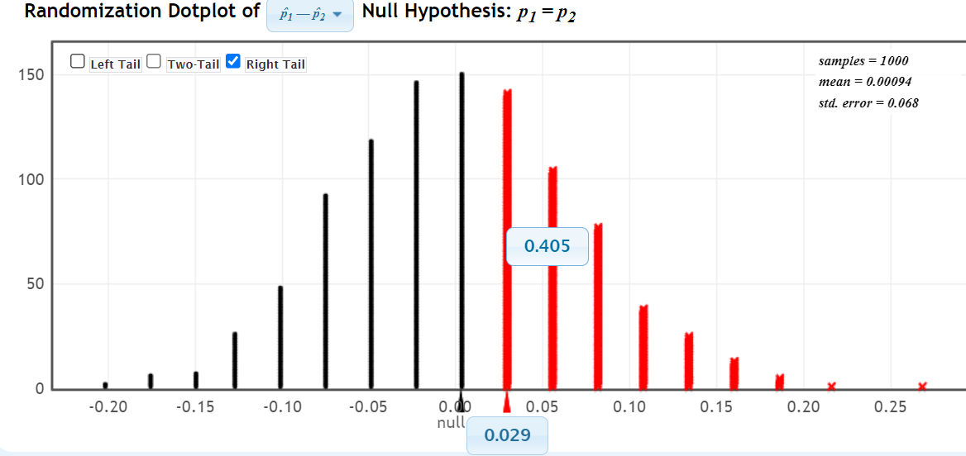

1. confidence interval for the difference of two independent proportions

We can find the confidence interval for the difference in A and B given above, at 90% confidence:

I get an interval of -.082 < pA – pB < +0.137, consistent with failing to reject the null hypothesis.